Course Name: | Web Development Laboratory | Semester: | III
Date of Performance: | ___ / ___ / ______ | DIV/ Batch No: | B1
Student Name: | Parth Joshi | Roll No: | 16010125090
Experiment No: 1
Title
Design and Development of Clinical Laboratory for Different Tests in Healthcare Sector Front-End using HTML5
Aim of the Experiment
To design and develop a multi-page, use-case-based web portal front-end using HTML5 for a Clinical Laboratory for Different Tests in Healthcare Sector using Calorimeter as a Point-of-Care Technology (KJS-HC-03), demonstrating proper HTML5 document structure, semantic elements, formatting, lists, hyperlinks, images, image maps, tables, forms, and multimedia elements.
Objectives of the Experiment
- Develop structured and semantic HTML5 web pages for a Clinical Laboratory Web Portal using appropriate HTML5 elements.
- Create interactive web pages for laboratory services such as patient registration, test information, sample collection, diagnostic reports, health packages, and contact details.
- Apply a real-world healthcare use case (Clinical Laboratory Management System) as the context for front-end web development using HTML5.
- Build a complete front-end web portal that serves as the foundation for further enhancement using CSS3, JavaScript, PHP, and modern web development frameworks.
COs to be achieved
CO1: Developing webpages using HTML and CSS.
Books / Journals / Websites references
- (Students should write — e.g., MDN Web Docs HTML5 reference, W3C.)

Theory
HTML5 is the latest version of HyperText Markup Language used to create structured and interactive web pages. It introduces semantic elements such as <header>, <nav>, <main>, <section>, <article>, and <footer>, which improve readability, accessibility, and search engine optimization.
HTML5 also supports multimedia elements such as <audio> and <video>, advanced form controls including email, date, number, and range input types, tables, hyperlinks, image maps, and embedded content using <iframe>. These features enable developers to build modern healthcare applications with improved usability and responsiveness.In this experiment, HTML5 is used to design the front-end of an AI-enabled Urine Test Strip Reader System. The portal provides facilities such as patient registration, urine test information, diagnostic reports, analyse details, multimedia awareness pages, and navigation between different healthcare services. The application serves laboratory technicians, doctors, pathologists, and patients by presenting diagnostic information in a structured and user-friendly manner.
Problem Statement
"Clinical Laboratory for Different Tests in Healthcare Sector"
A multi-specialty diagnostic center plans to develop an HTML5-based Clinical Laboratory Web Portal to provide information about laboratory tests, online patient registration, sample collection, diagnostic reports, health packages, and laboratory services. The portal will enable patients, doctors, and laboratory technicians to access laboratory information and services efficiently."
A healthcare organization wants to develop a basic HTML5-based web portal front-end for an AI-enabled Urine Test Strip Reader System. The portal should display patient information, urine test parameters, analyse concentrations, diagnostic reports, awareness material, and healthcare services for doctors, laboratory technicians, and patients.
Each task below contributes one page or feature of this healthcare portal, representing different modules of the Urine Test Strip Reader system.
Task 1: Create the Homepage Structure
Scenario
Design the homepage of the Clinical Laboratory Management System.
Requirements
· Use proper HTML5 document structure tags:
o <header>, <nav>, <section>, <article>, <aside>, <footer>
· Header must contain:
o Laboratory Name in <h1>
o Tagline: "Accurate Diagnostics for Better Healthcare"
· Navigation menu with links:
o Home
o Laboratory Tests
o Health Packages
o Online Registration
o Reports
o Contact Us
· Footer with copyright information.
Concepts Tested
· HTML5 document structure
· Semantic elements
· Headings
· Hyperlinks
Deliverable: index.html
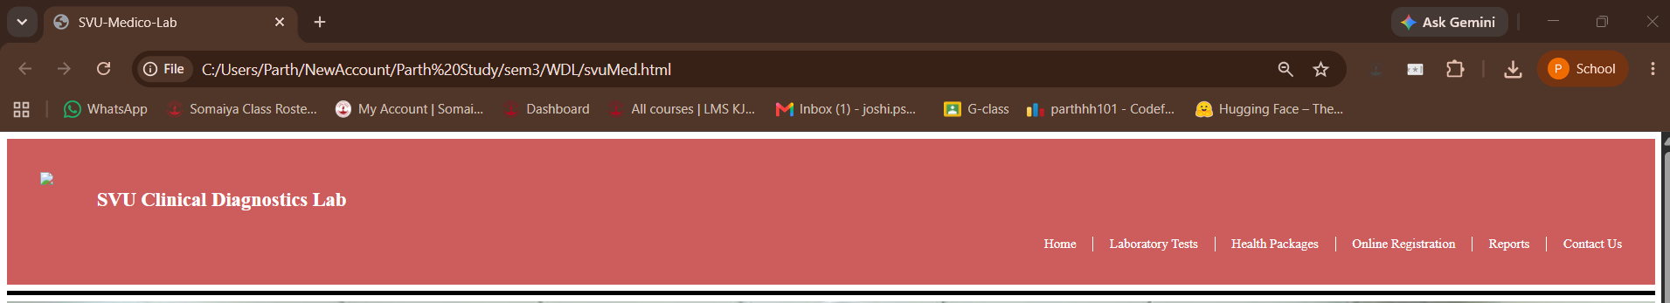

Task 2: Display Laboratory Tests using Lists
Scenario
Display various laboratory services offered by the diagnostic center.
Requirements
Create
Ordered List
· Patient Testing Process
1. Patient Registration
2. Sample Collection
3. Laboratory Testing
4. Report Generation
5. Doctor Consultation
Unordered List
· Types of Laboratory Tests
o Blood Tests
o Urine Tests
o Thyroid Profile
o Liver Function Test
o Kidney Function Test
o Lipid Profile
o Diabetes Tests
Description List
Explain
· CBC
· HbA1c
· LFT
· KFT
· ECG
Use formatting tags
· <b>
· <i>
· <mark>
Concepts Tested
· Lists
· Formatting Tags
· Text-Level Formatting
Deliverable: laboratory-tests.html

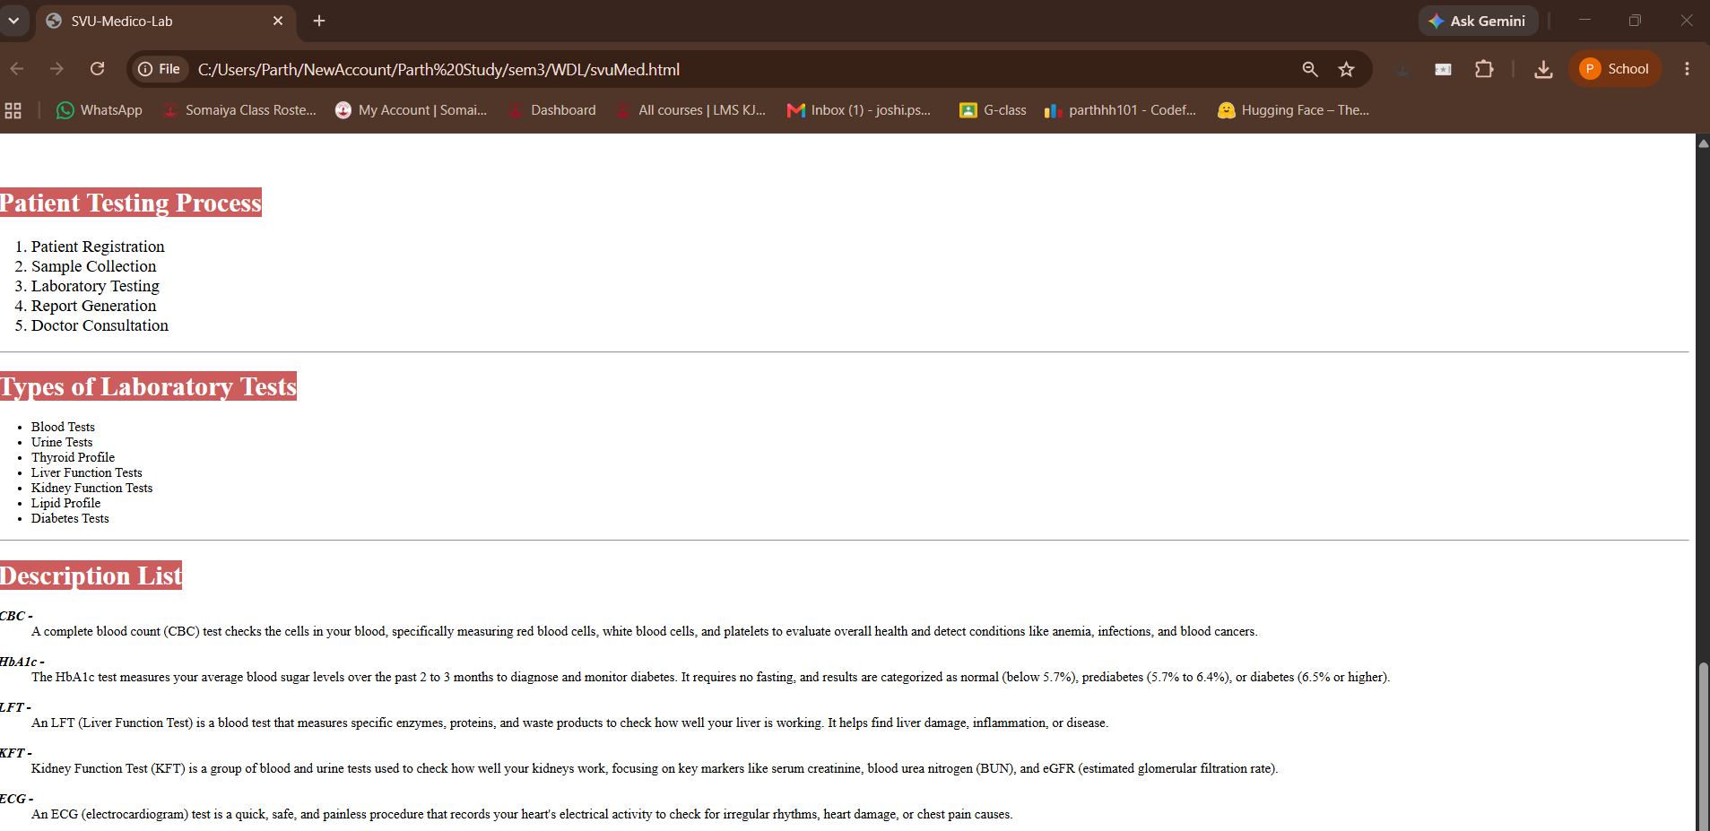

Task 3: Laboratory Test Details Page
Scenario
Create a page displaying complete details of a diagnostic test.
Requirements
Display
· Test Name
· Purpose
· Sample Required
· Preparation Instructions
· Normal Reference Range
· Report Delivery Time
Highlight
· Important Instructions
· Fasting Requirements
Use
· <strong>
· <em>
· <mark>
· <small>
· <br>
· <hr>
Concepts Tested
· Block-level Elements
· Inline Formatting
· HTML Formatting Tags
Deliverable: test-details.html
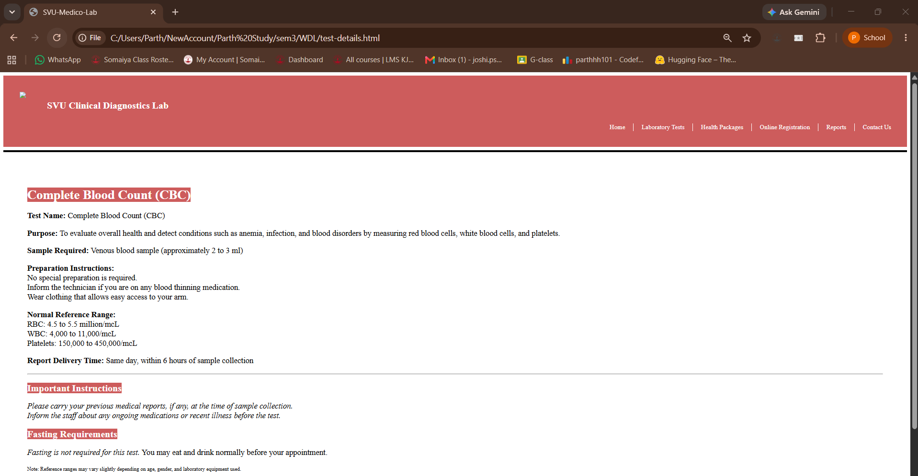

Task 4: Laboratory Gallery using Images
Scenario
Create a gallery showcasing laboratory infrastructure.
Requirements
Display images of
· Clinical Laboratory
· Blood Collection Room
· Automated Analyzer
· Sample Processing Area
Each image should
· Open a detailed information page
· Include
o alt
o title
o width
o height
Use
· <figure>
· <figcaption>
Concepts Tested
· Images
· Hyperlinks
· Global Attributes
Deliverable: gallery.html

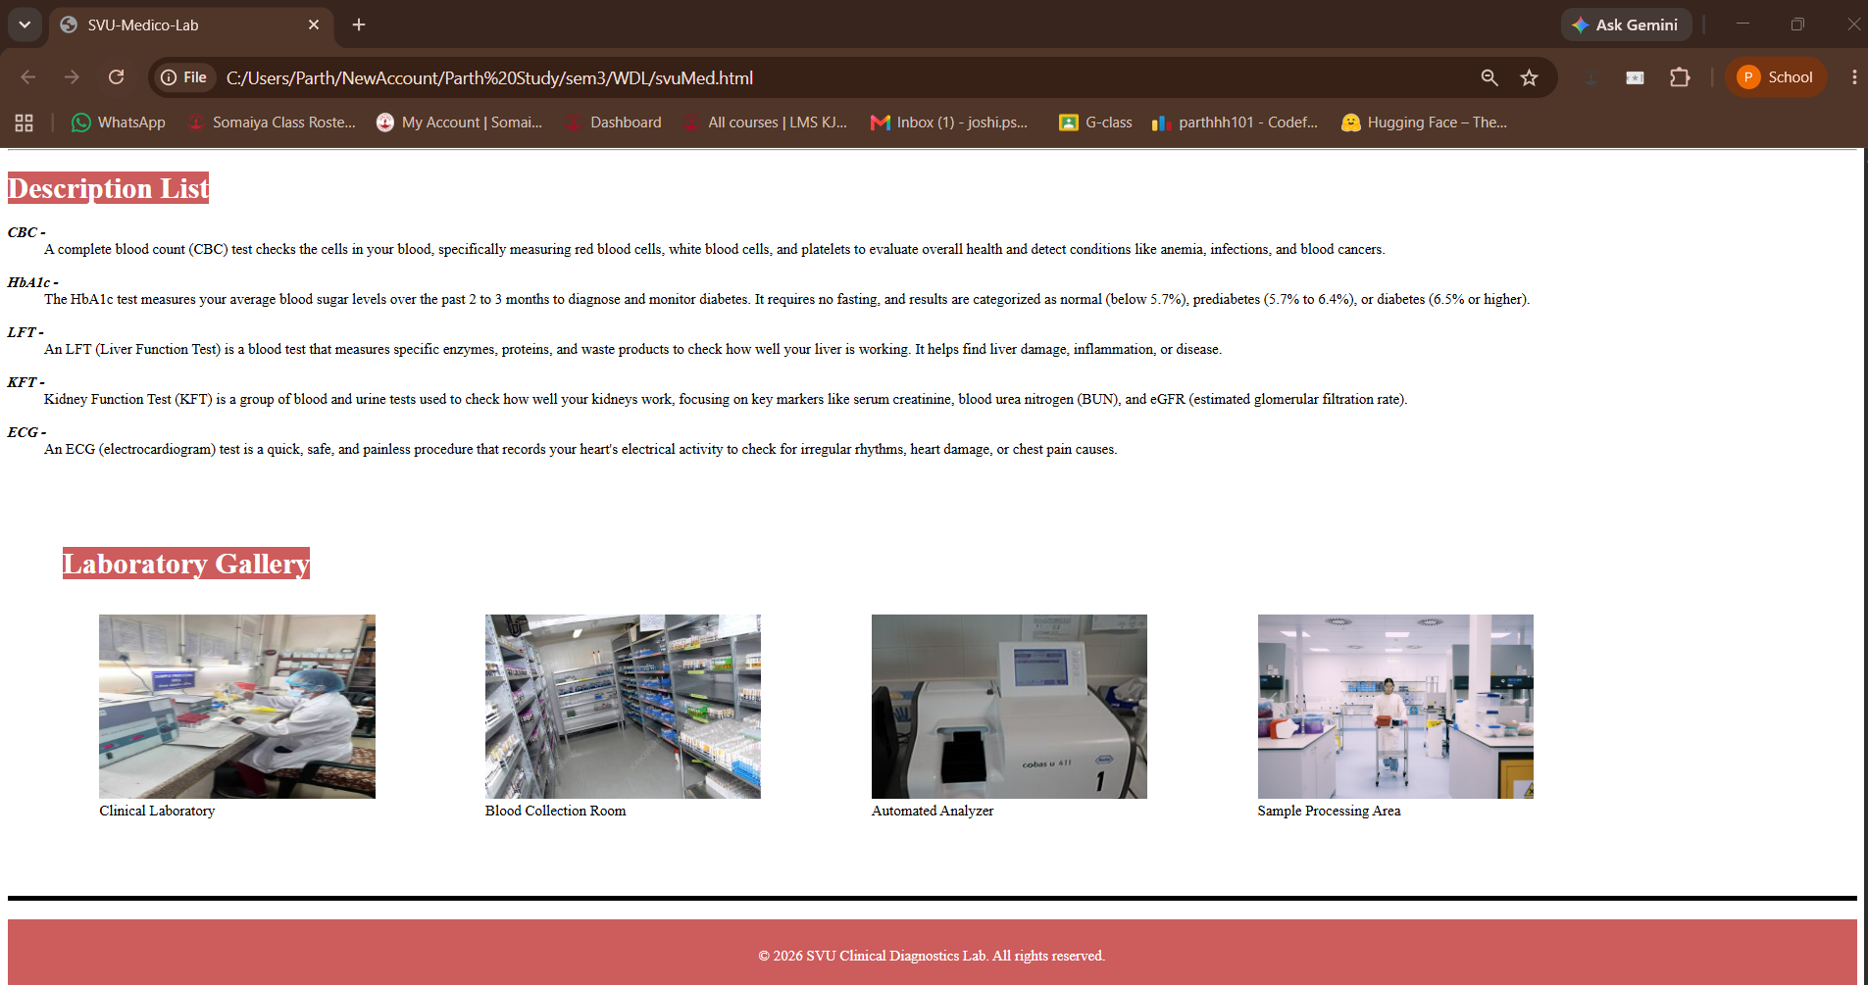

Use
· <map>
· <area>
Task 5: Interactive Image Map of Test Strip
Scenario
Provide an interactive urine test strip.
Requirements
Display a urine test strip image.
Create clickable regions for
· Glucose Pad
· Protein Pad
· Blood Pad
· Ketone Pad
· pH Pad
Concepts Tested
· Image Maps
· Hyperlinks
Deliverable: lab-map.html
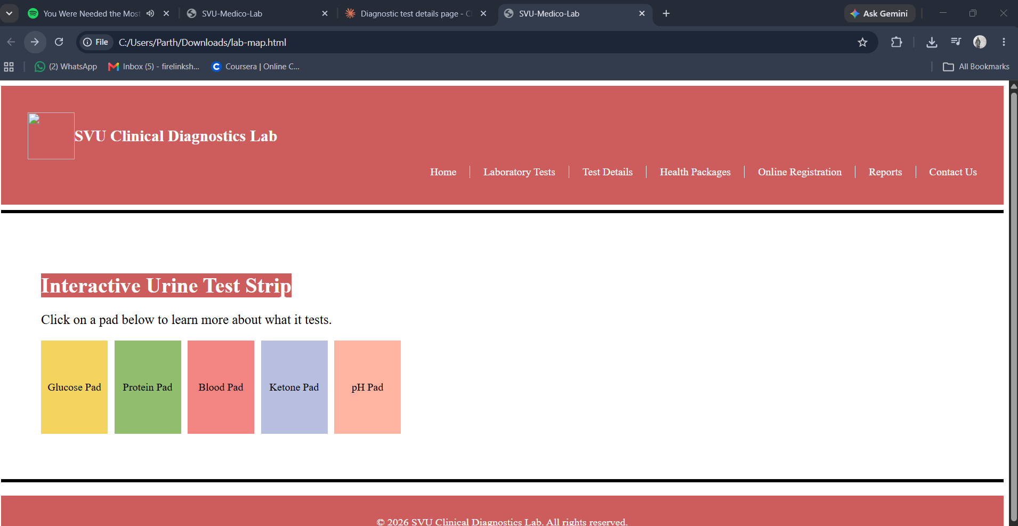

Task 6: Laboratory Test Price Table
Scenario
Display available laboratory tests and charges.

Requirements
Create a table with
· Test Code
· Test Name
· Department
· Cost
· Sample Type
· Report Time
Use
· <caption>
· <thead>
· <tbody>
· <tfoot>
· rowspan
· colspan
Apply suitable formatting.
Concepts Tested
· HTML Tables
· Table Formatting
Deliverable: test-price-table.html
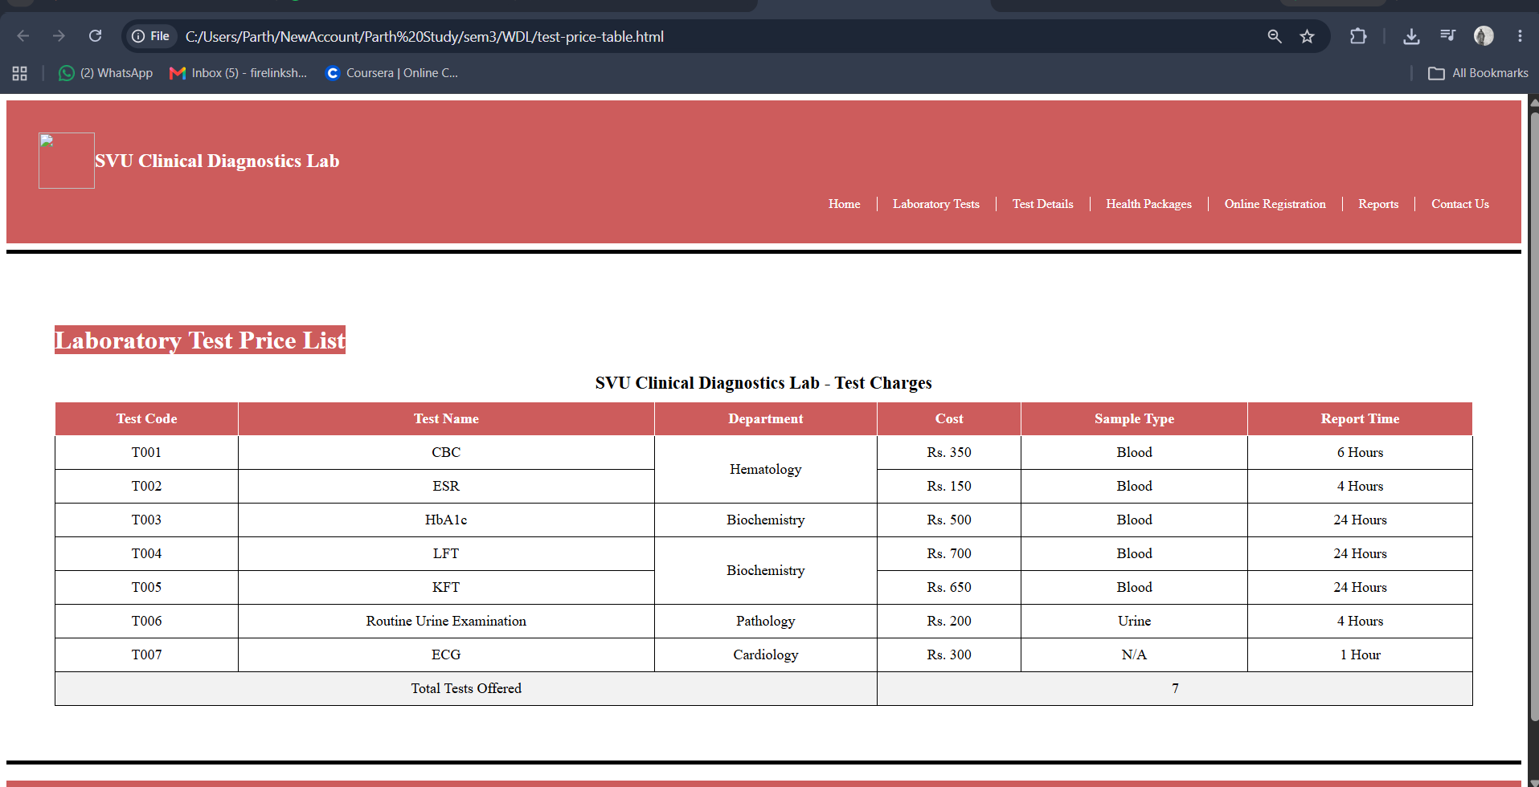

Task 7: Online Patient Registration Form
Scenario
Develop an online patient registration page.
Requirements
Create form controls for
· Patient Name
· Age
· Gender
· Mobile Number
· Email
· Date of Birth
· Test Selection
· Preferred Appointment Date
· Sample Collection Preference
· Upload Doctor Prescription
Include
· <label>
· <fieldset>
· <legend>
Apply HTML5 validation
· required
· placeholder
· pattern
· autofocus
Concepts Tested
· HTML Forms
· HTML5 Input Types
· Validation Attributes
Deliverable: patient-registration.html
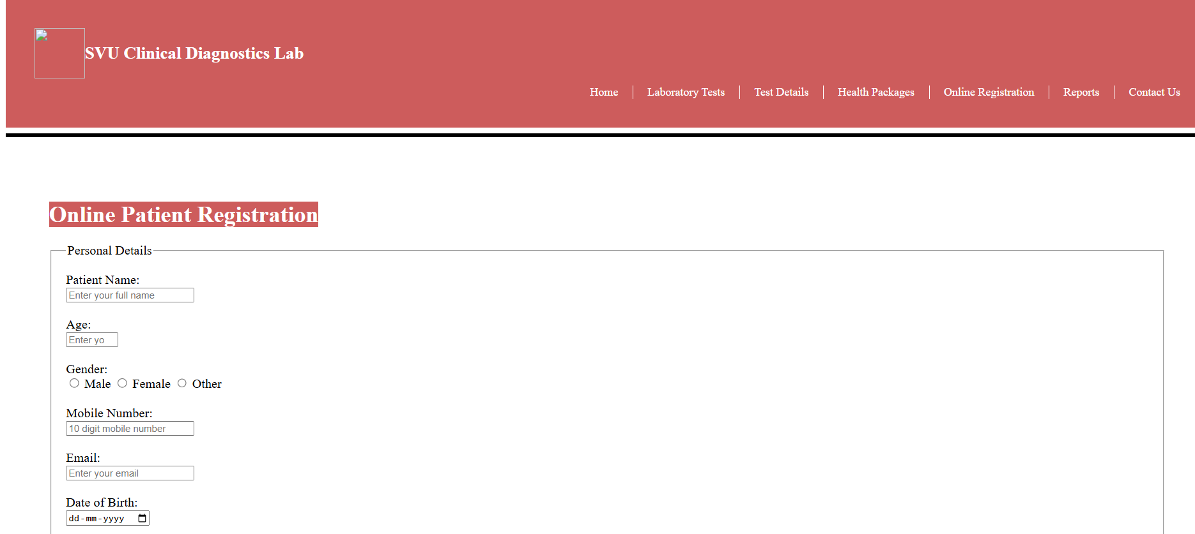
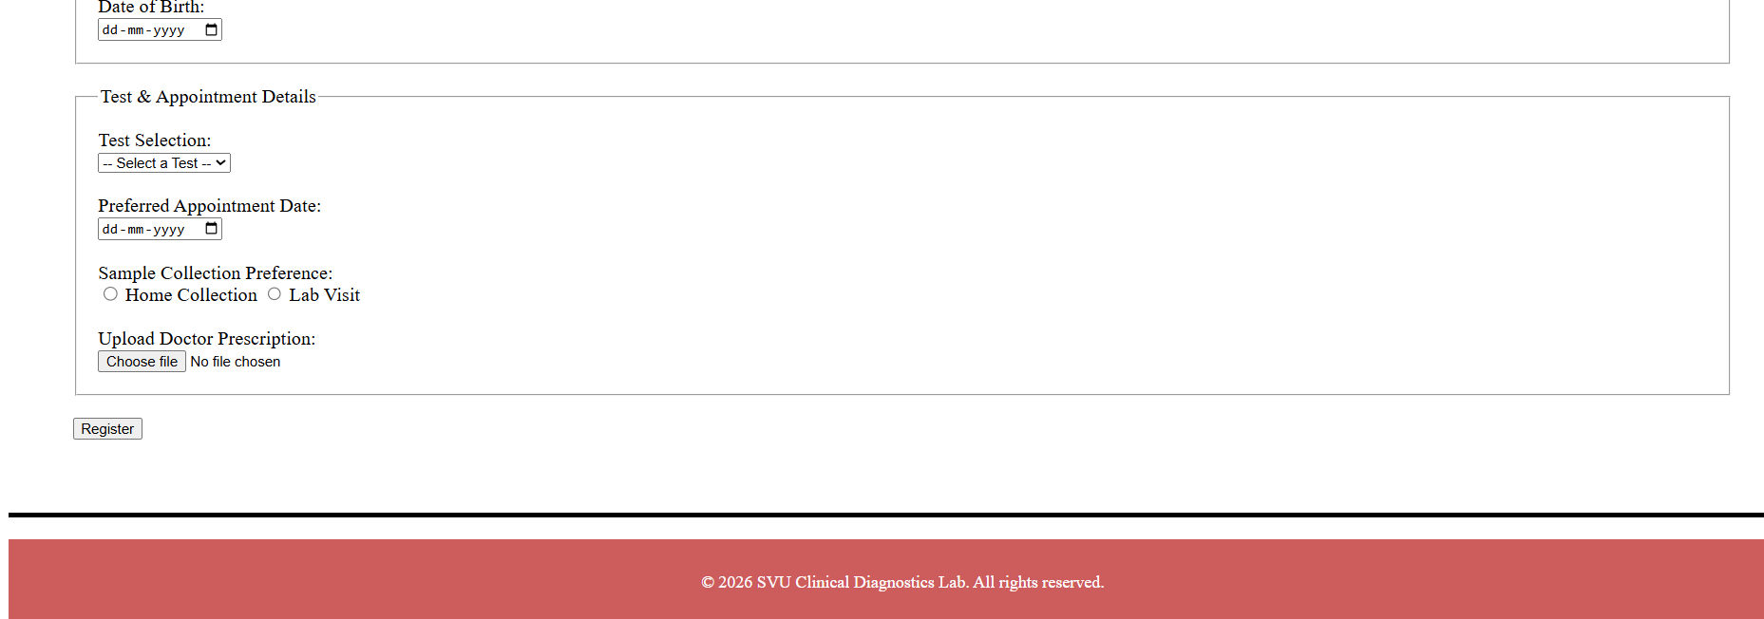

Task 8: Embed Health Information using IFrame
Scenario
Provide useful health resources for patients.
Requirements
Embed
· National Health Portal
· Google Maps showing laboratory location
Use
· <iframe>
Place the content under
Health Information Centre
Concepts Tested
· IFrame
· External Web Resources
Deliverable: health-information.html
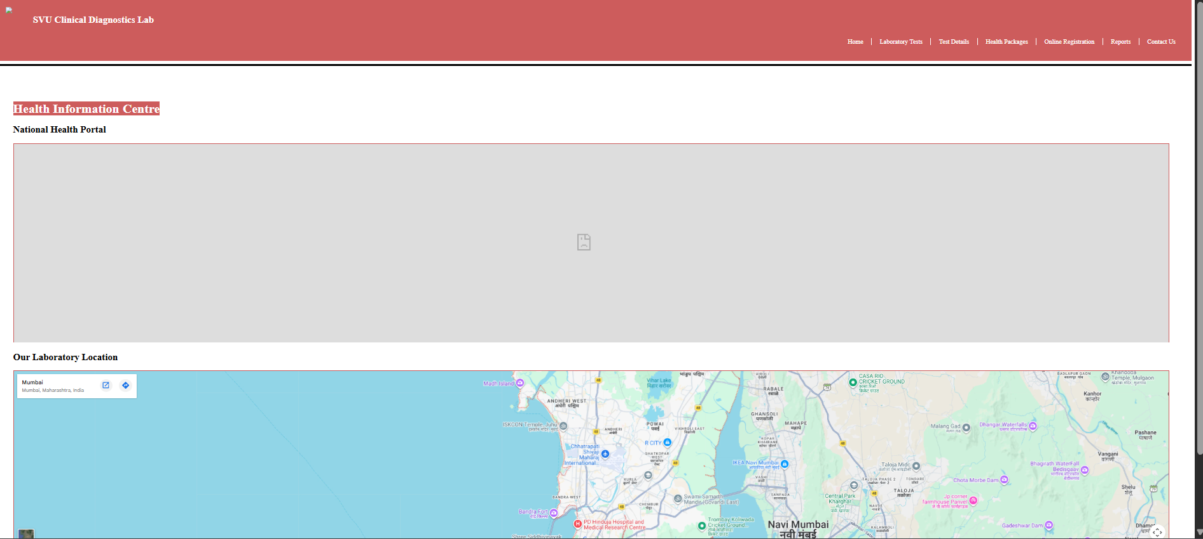

Task 9: Add Multimedia & Executable Content
Scenario
Create a patient awareness page.
Requirements
Add
· Video explaining laboratory sample collection procedures
· Audio instructions for patients before testing
· JavaScript alert
Welcome to the Clinical Laboratory Management System
Use
· <video>
· <audio>
· <script>
Enable
· controls
· autoplay
· loop
Concepts Tested
· Multimedia
· JavaScript
· Executable Content
Deliverable: media.html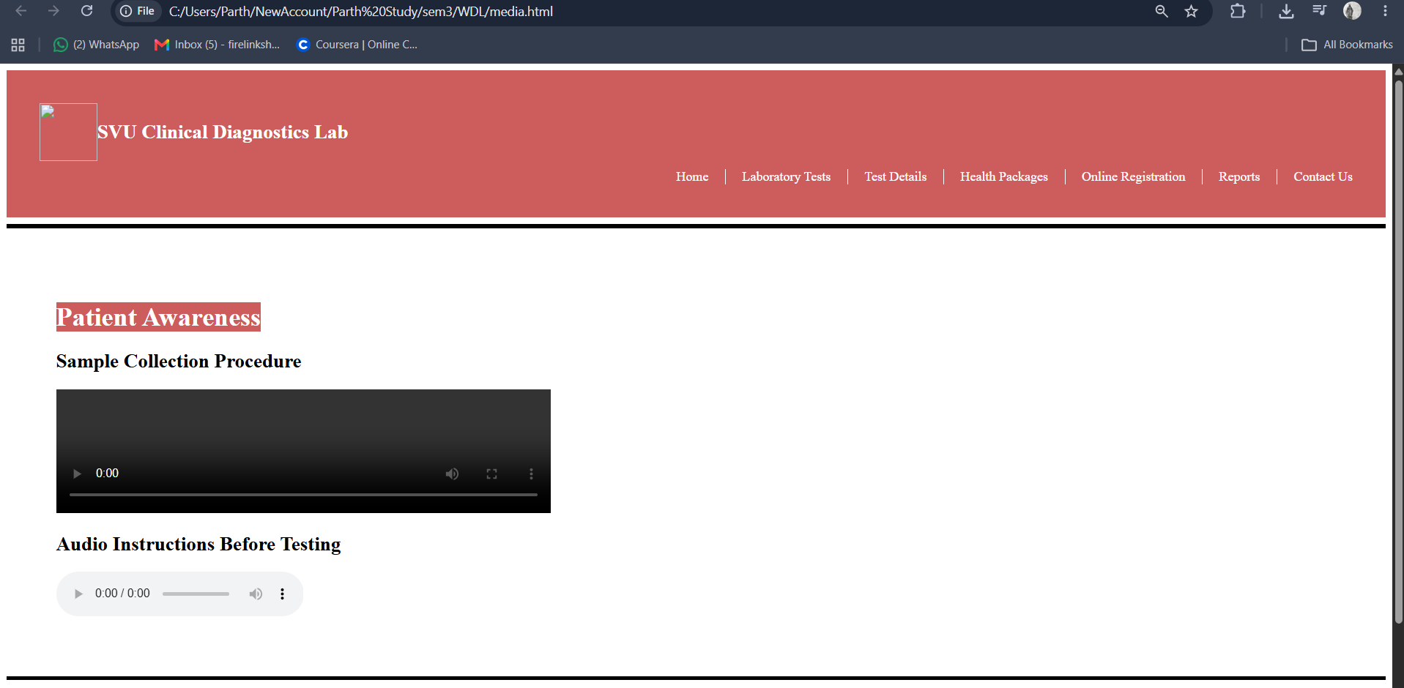

Code :
HOMEPAGE:
<!DOCTYPE html>
<html>
<head>
<title> SVU-Medico-Lab</title>
<meta name="viewport" content="width=device-width, initial-scale=1.0">
</head>
<body>
<div style="background-color: IndianRed; color: white; padding: 40px;">
<div style="display:flex; align-items: center;">
<img src="logo_white_transparent.png" width="70" height="70">
<h1 style="font-size: 24px;"> SVU Clinical Diagnostics Lab </h1>
</div>
<nav style="display:flex; justify-content:flex-end; margin-top:10px;">
<ul style="display:flex; list-style:none; padding:0; margin:0; gap:20px;">
<li><a href="svuMed.html" style="color:white; text-decoration:none;">Home</a></li>
<li style="border-left:1px solid white; padding-left:20px;"><a href="laboratory-tests.html" style="color:white; text-decoration:none;">Laboratory Tests</a></li>
<li style="border-left:1px solid white; padding-left:20px;"><a href="test-details.html" style="color:white; text-decoration:none;">Test Details</a></li>
<li style="border-left:1px solid white; padding-left:20px;"><a href="health-packages.html" style="color:white; text-decoration:none;">Health Packages</a></li>
<li style="border-left:1px solid white; padding-left:20px;"><a href="patient-registration.html" style="color:white; text-decoration:none;">Online Registration</a></li>
<li style="border-left:1px solid white; padding-left:20px;"><a href="reports.html" style="color:white; text-decoration:none;">Reports</a></li>
<li style="border-left:1px solid white; padding-left:20px;"><a href="contact.html" style="color:white; text-decoration:none;">Contact Us</a></li>
</ul>
</nav>

</div>
<hr style="height: 5px; background-color: black; border: none;">

<div style="position:relative; text-align:center;">
<img src="1.jpg" style="width:100%; height:auto; opacity:0.8;">
<h2 style="position:absolute; top:28%; left:11%; color:navy; font-size:90px;">
Accurate Diagnostics for <br>Better Healthcare</br>
</h2>
</div>
<hr style="height: 5px; background-color: black; border: none;">

<div style="display:flex; align-items:center; gap:20px; padding:60px;">
<img src="3.jpg" style="width:550px; height:400px;" alt="Description">
<center>
<h1> What We Do. </h1>
<p style="font-size:25px; line-height:1.6;">
At SVU Clinical Diagnostics Lab, we provide accurate and timely diagnostic
testing across blood, urine, thyroid, liver, and kidney profiles. Our
state-of-the-art analyzers and experienced technicians ensure reliable results,
fast report delivery, and compassionate patient care because your health
deserves precision you can trust.
</p>
</center>
</div>

<div>
<h1> <mark style = "background-color: IndianRed; color: white"> Patient Testing Process </mark></h1>
<ol style = "font-size: 20px">
<li> Patient Registration </li>
<li> Sample Collection </li>
<li> Laboratory Testing </li>
<li> Report Generation </li>
<li> Doctor Consultation </li>
</ol>
<hr>
<h1> <mark style = "background-color: IndianRed; color: white"> Types of Laboratory Tests </h1>
<ul style = "font-size = 20px">
<li> Blood Tests </li>
<li> Urine Tests </li>
<li> Thyroid Profile </li>
<li> Liver Function Tests </li>
<li> Kidney Function Tests </li>
<li> Lipid Profile </li>
<li> Diabetes Tests </li>
</ul>
<hr>

<h1> <mark style = "background-color: IndianRed; color: white"> Description List </h1>
<dl>
<dt> <b> <i> CBC - </b> </dt> </i> <dd> <span>A complete blood count (CBC) test checks the cells in your blood, specifically measuring red blood cells, white blood cells, and platelets to evaluate overall health and detect conditions like anemia, infections, and blood cancers. </span> </dd>
<br>
<dt> <b> <i> HbA1c - </b> </dt> </i> <span> <dd> The HbA1c test measures your average blood sugar levels over the past 2 to 3 months to diagnose and monitor diabetes. It requires no fasting, and results are categorized as normal (below 5.7%), prediabetes (5.7% to 6.4%), or diabetes (6.5% or higher). </span> </dd>
<br>
<dt> <b> <i> LFT - </b></dt> </i> <span> <dd> An LFT (Liver Function Test) is a blood test that measures specific enzymes, proteins, and waste products to check how well your liver is working. It helps find liver damage, inflammation, or disease. </span> </dd>
<br>
<dt> <b> <i> KFT - </b> </dt> </i> <span> <dd> Kidney Function Test (KFT) is a group of blood and urine tests used to check how well your kidneys work, focusing on key markers like serum creatinine, blood urea nitrogen (BUN), and eGFR (estimated glomerular filtration rate). </span> </dd>
<br>
<dt> <b> <i> ECG - </b> </i> </dt> <span> <dd> An ECG (electrocardiogram) test is a quick, safe, and painless procedure that records your heart's electrical activity to check for irregular rhythms, heart damage, or chest pain causes.</span> </dd>
</div>

<div style="padding:60px;">
<h1> <mark style = "background-color: IndianRed; color: white"> Laboratory Gallery </mark></h1>

<div style="display:flex; flex-wrap:wrap; gap:40px;">

<figure>
<img src="clinical-lab.jpg" alt="Clinical Laboratory" title="Clinical Laboratory" width="300" height="200">
<figcaption>Clinical Laboratory</figcaption>
</figure>

<figure>
<img src="blood-collection-room.jpg" alt="Blood Collection Room" title="Blood Collection Room" width="300" height="200">
<figcaption>Blood Collection Room</figcaption>
</figure>

<figure>
<img src="automated-analyzer.jpg" alt="Automated Analyzer" title="Automated Analyzer" width="300" height="200">
<figcaption>Automated Analyzer</figcaption>
</figure>

<figure>
<img src="sample-processing-area.jpg" alt="Sample Processing Area" title="Sample Processing Area" width="300" height="200">
<figcaption>Sample Processing Area</figcaption>
</figure>

</div>
</div>
<hr style="height: 5px; background-color: black; border: none;">

<footer style="background-color: IndianRed; color: white; text-align:center; padding:15px; margin-top:20px;">
<p>&copy; 2026 SVU Clinical Diagnostics Lab. All rights reserved.</p>
</footer>
</body>

</html>

Lab-map.html
<!DOCTYPE html>
<html>
<head>
<title> SVU-Medico-Lab</title>
<meta name="viewport" content="width=device-width, initial-scale=1.0">
</head>
<body>
<div style="background-color: IndianRed; color: white; padding: 40px;">
<div style="display:flex; align-items: center;">
<img src="logo_white_transparent.png" width="70" height="70">
<h1 style="font-size: 24px;"> SVU Clinical Diagnostics Lab </h1>
</div>
<nav style="display:flex; justify-content:flex-end; margin-top:10px;">
<ul style="display:flex; list-style:none; padding:0; margin:0; gap:20px;">
<li><a href="svuMed.html" style="color:white; text-decoration:none;">Home</a></li>
<li style="border-left:1px solid white; padding-left:20px;"><a href="laboratory-tests.html" style="color:white; text-decoration:none;">Laboratory Tests</a></li>
<li style="border-left:1px solid white; padding-left:20px;"><a href="test-details.html" style="color:white; text-decoration:none;">Test Details</a></li>
<li style="border-left:1px solid white; padding-left:20px;"><a href="health-packages.html" style="color:white; text-decoration:none;">Health Packages</a></li>
<li style="border-left:1px solid white; padding-left:20px;"><a href="patient-registration.html" style="color:white; text-decoration:none;">Online Registration</a></li>
<li style="border-left:1px solid white; padding-left:20px;"><a href="reports.html" style="color:white; text-decoration:none;">Reports</a></li>
<li style="border-left:1px solid white; padding-left:20px;"><a href="contact.html" style="color:white; text-decoration:none;">Contact Us</a></li>
</ul>
</nav>
</div>
<hr style="height: 5px; background-color: black; border: none;">

<div style="padding:60px;">
<h1> <mark style="background-color: IndianRed; color: white"> Interactive Urine Test Strip </mark></h1>
<p style="font-size:20px;"> Click on a pad below to learn more about what it tests. </p>

<div style="display:flex; gap:10px;">
<a href="glucose-pad.html" style="display:block; width:100px; height:140px; background-color:#f4d35e; color:black; text-align:center; line-height:140px; text-decoration:none;">Glucose Pad</a>
<a href="protein-pad.html" style="display:block; width:100px; height:140px; background-color:#90be6d; color:black; text-align:center; line-height:140px; text-decoration:none;">Protein Pad</a>
<a href="blood-pad.html" style="display:block; width:100px; height:140px; background-color:#f28482; color:black; text-align:center; line-height:140px; text-decoration:none;">Blood Pad</a>
<a href="ketone-pad.html" style="display:block; width:100px; height:140px; background-color:#b8bedd; color:black; text-align:center; line-height:140px; text-decoration:none;">Ketone Pad</a>
<a href="ph-pad.html" style="display:block; width:100px; height:140px; background-color:#ffb4a2; color:black; text-align:center; line-height:140px; text-decoration:none;">pH Pad</a>
</div>
</div>

<hr style="height: 5px; background-color: black; border: none;">
<footer style="background-color: IndianRed; color: white; text-align:center; padding:15px; margin-top:20px;">
<p>&copy; 2026 SVU Clinical Diagnostics Lab. All rights reserved.</p>
</footer>
</body>

</html>

Media.html
<!DOCTYPE html>
<html>
<head>
<title> SVU-Medico-Lab</title>
<meta name="viewport" content="width=device-width, initial-scale=1.0">
</head>
<body>
<div style="background-color: IndianRed; color: white; padding: 40px;">
<div style="display:flex; align-items: center;">
<img src="logo_white_transparent.png" width="70" height="70">
<h1 style="font-size: 24px;"> SVU Clinical Diagnostics Lab </h1>
</div>
<nav style="display:flex; justify-content:flex-end; margin-top:10px;">
<ul style="display:flex; list-style:none; padding:0; margin:0; gap:20px;">
<li><a href="svuMed.html" style="color:white; text-decoration:none;">Home</a></li>
<li style="border-left:1px solid white; padding-left:20px;"><a href="laboratory-tests.html" style="color:white; text-decoration:none;">Laboratory Tests</a></li>
<li style="border-left:1px solid white; padding-left:20px;"><a href="test-details.html" style="color:white; text-decoration:none;">Test Details</a></li>
<li style="border-left:1px solid white; padding-left:20px;"><a href="health-packages.html" style="color:white; text-decoration:none;">Health Packages</a></li>
<li style="border-left:1px solid white; padding-left:20px;"><a href="patient-registration.html" style="color:white; text-decoration:none;">Online Registration</a></li>
<li style="border-left:1px solid white; padding-left:20px;"><a href="reports.html" style="color:white; text-decoration:none;">Reports</a></li>
<li style="border-left:1px solid white; padding-left:20px;"><a href="contact.html" style="color:white; text-decoration:none;">Contact Us</a></li>
</ul>
</nav>
</div>
<hr style="height: 5px; background-color: black; border: none;">

<div style="padding:60px;">
<h1> <mark style="background-color: IndianRed; color: white"> Patient Awareness </mark></h1>

<h2>Sample Collection Procedure</h2>
<video width="600" controls loop>
<source src="sample-collection.mp4" type="video/mp4">
</video>

<h2>Audio Instructions Before Testing</h2>
<audio controls autoplay>
<source src="patient-instructions.mp3" type="audio/mpeg">
</audio>
</div>

<hr style="height: 5px; background-color: black; border: none;">
<footer style="background-color: IndianRed; color: white; text-align:center; padding:15px; margin-top:20px;">
<p>&copy; 2026 SVU Clinical Diagnostics Lab. All rights reserved.</p>
</footer>

<script>
alert("Welcome to the Clinical Laboratory Management System");
</script>
</body>

</html>

Patient registration.html
<!DOCTYPE html>
<html>
<head>
<title> SVU-Medico-Lab</title>
<meta name="viewport" content="width=device-width, initial-scale=1.0">
</head>
<body>
<div style="background-color: IndianRed; color: white; padding: 40px;">
<div style="display:flex; align-items: center;">
<img src="logo_white_transparent.png" width="70" height="70">
<h1 style="font-size: 24px;"> SVU Clinical Diagnostics Lab </h1>
</div>
<nav style="display:flex; justify-content:flex-end; margin-top:10px;">
<ul style="display:flex; list-style:none; padding:0; margin:0; gap:20px;">
<li><a href="svuMed.html" style="color:white; text-decoration:none;">Home</a></li>
<li style="border-left:1px solid white; padding-left:20px;"><a href="laboratory-tests.html" style="color:white; text-decoration:none;">Laboratory Tests</a></li>
<li style="border-left:1px solid white; padding-left:20px;"><a href="test-details.html" style="color:white; text-decoration:none;">Test Details</a></li>
<li style="border-left:1px solid white; padding-left:20px;"><a href="health-packages.html" style="color:white; text-decoration:none;">Health Packages</a></li>
<li style="border-left:1px solid white; padding-left:20px;"><a href="patient-registration.html" style="color:white; text-decoration:none;">Online Registration</a></li>
<li style="border-left:1px solid white; padding-left:20px;"><a href="reports.html" style="color:white; text-decoration:none;">Reports</a></li>
<li style="border-left:1px solid white; padding-left:20px;"><a href="contact.html" style="color:white; text-decoration:none;">Contact Us</a></li>
</ul>
</nav>
</div>
<hr style="height: 5px; background-color: black; border: none;">

<div style="padding:60px;">
<h1> <mark style="background-color: IndianRed; color: white"> Online Patient Registration </mark></h1>

<form style="font-size:18px;">
<fieldset style="margin-bottom:20px; padding:20px;">
<legend>Personal Details</legend>

<label for="pname">Patient Name:</label><br>
<input type="text" id="pname" name="pname" placeholder="Enter your full name" required autofocus><br><br>

<label for="page">Age:</label><br>
<input type="number" id="page" name="page" placeholder="Enter your age" min="1" max="120" required><br><br>

<label>Gender:</label><br>
<input type="radio" id="male" name="gender" value="Male" required>
<label for="male">Male</label>
<input type="radio" id="female" name="gender" value="Female">
<label for="female">Female</label>
<input type="radio" id="other" name="gender" value="Other">
<label for="other">Other</label><br><br>

<label for="mobile">Mobile Number:</label><br>
<input type="tel" id="mobile" name="mobile" placeholder="10 digit mobile number" pattern="[0-9]{10}" required><br><br>

<label for="email">Email:</label><br>
<input type="email" id="email" name="email" placeholder="Enter your email" required><br><br>

<label for="dob">Date of Birth:</label><br>
<input type="date" id="dob" name="dob" required>
</fieldset>

<fieldset style="margin-bottom:20px; padding:20px;">
<legend>Test & Appointment Details</legend>

<label for="testselect">Test Selection:</label><br>
<select id="testselect" name="testselect" required>
<option value="">-- Select a Test --</option>
<option value="CBC">CBC</option>
<option value="HbA1c">HbA1c</option>
<option value="LFT">LFT</option>
<option value="KFT">KFT</option>
<option value="ECG">ECG</option>
</select><br><br>

<label for="appointmentdate">Preferred Appointment Date:</label><br>
<input type="date" id="appointmentdate" name="appointmentdate" required><br><br>

<label>Sample Collection Preference:</label><br>
<input type="radio" id="homecollection" name="collection" value="Home Collection" required>
<label for="homecollection">Home Collection</label>
<input type="radio" id="labvisit" name="collection" value="Lab Visit">
<label for="labvisit">Lab Visit</label><br><br>

<label for="prescription">Upload Doctor Prescription:</label><br>
<input type="file" id="prescription" name="prescription" accept=".pdf,.jpg,.jpeg,.png">
</fieldset>

<button type="submit">Register</button>
</form>
</div>

<hr style="height: 5px; background-color: black; border: none;">
<footer style="background-color: IndianRed; color: white; text-align:center; padding:15px; margin-top:20px;">
<p>&copy; 2026 SVU Clinical Diagnostics Lab. All rights reserved.</p>
</footer>
</body>

</html>

Test-details. Html
<!DOCTYPE html>
<html>
<head>
<title> SVU-Medico-Lab</title>
<meta name="viewport" content="width=device-width, initial-scale=1.0">
</head>
<body>
<div style="background-color: IndianRed; color: white; padding: 40px;">
<div style="display:flex; align-items: center;">
<img src="logo_white_transparent.png" width="70" height="70">
<h1 style="font-size: 24px;"> SVU Clinical Diagnostics Lab </h1>
</div>
<nav style="display:flex; justify-content:flex-end; margin-top:10px;">
<ul style="display:flex; list-style:none; padding:0; margin:0; gap:20px;">
<li><a href="svuMed.html" style="color:white; text-decoration:none;">Home</a></li>
<li style="border-left:1px solid white; padding-left:20px;"><a href="laboratory-tests.html" style="color:white; text-decoration:none;">Laboratory Tests</a></li>
<li style="border-left:1px solid white; padding-left:20px;"><a href="health-packages.html" style="color:white; text-decoration:none;">Health Packages</a></li>
<li style="border-left:1px solid white; padding-left:20px;"><a href="patient-registration.html" style="color:white; text-decoration:none;">Online Registration</a></li>
<li style="border-left:1px solid white; padding-left:20px;"><a href="reports.html" style="color:white; text-decoration:none;">Reports</a></li>
<li style="border-left:1px solid white; padding-left:20px;"><a href="contact.html" style="color:white; text-decoration:none;">Contact Us</a></li>
</ul>
</nav>
</div>
<hr style="height: 5px; background-color: black; border: none;">

<div style="padding:60px;">
<h1> <mark style="background-color: IndianRed; color: white"> Complete Blood Count (CBC) </mark></h1>

<p style="font-size:20px;"> <strong>Test Name:</strong> Complete Blood Count (CBC) </p>

<p style="font-size:20px;"> <strong>Purpose:</strong> To evaluate overall health and detect conditions such as anemia, infection, and blood disorders by measuring red blood cells, white blood cells, and platelets. </p>

<p style="font-size:20px;"> <strong>Sample Required:</strong> Venous blood sample (approximately 2 to 3 ml) </p>

<p style="font-size:20px;"> <strong>Preparation Instructions:</strong> <br>
No special preparation is required. <br>
Inform the technician if you are on any blood thinning medication. <br>
Wear clothing that allows easy access to your arm. </p>

<p style="font-size:20px;"> <strong>Normal Reference Range:</strong> <br>
RBC: 4.5 to 5.5 million/mcL <br>
WBC: 4,000 to 11,000/mcL <br>
Platelets: 150,000 to 450,000/mcL </p>

<p style="font-size:20px;"> <strong>Report Delivery Time:</strong> Same day, within 6 hours of sample collection </p>

<hr>

<h2> <mark style="background-color: IndianRed; color: white"> Important Instructions </mark> </h2>
<p style="font-size:20px;"> <em>Please carry your previous medical reports, if any, at the time of sample collection.</em> <br>
<em>Inform the staff about any ongoing medications or recent illness before the test.</em> </p>

<h2> <mark style="background-color: IndianRed; color: white"> Fasting Requirements </mark> </h2>
<p style="font-size:20px;"> <em>Fasting is not required for this test.</em> You may eat and drink normally before your appointment. </p>

<small> Note: Reference ranges may vary slightly depending on age, gender, and laboratory equipment used. </small>
</div>

<hr style="height: 5px; background-color: black; border: none;">

<footer style="background-color: IndianRed; color: white; text-align:center; padding:15px; margin-top:20px;">
<p>&copy; 2026 SVU Clinical Diagnostics Lab. All rights reserved.</p>
</footer>
</body>

</html>
Test-price-table.html
<!DOCTYPE html>
<html>
<head>
<title> SVU-Medico-Lab</title>
<meta name="viewport" content="width=device-width, initial-scale=1.0">
</head>
<body>
<div style="background-color: IndianRed; color: white; padding: 40px;">
<div style="display:flex; align-items: center;">
<img src="logo_white_transparent.png" width="70" height="70">
<h1 style="font-size: 24px;"> SVU Clinical Diagnostics Lab </h1>
</div>
<nav style="display:flex; justify-content:flex-end; margin-top:10px;">
<ul style="display:flex; list-style:none; padding:0; margin:0; gap:20px;">
<li><a href="svuMed.html" style="color:white; text-decoration:none;">Home</a></li>
<li style="border-left:1px solid white; padding-left:20px;"><a href="laboratory-tests.html" style="color:white; text-decoration:none;">Laboratory Tests</a></li>
<li style="border-left:1px solid white; padding-left:20px;"><a href="test-details.html" style="color:white; text-decoration:none;">Test Details</a></li>
<li style="border-left:1px solid white; padding-left:20px;"><a href="health-packages.html" style="color:white; text-decoration:none;">Health Packages</a></li>
<li style="border-left:1px solid white; padding-left:20px;"><a href="patient-registration.html" style="color:white; text-decoration:none;">Online Registration</a></li>
<li style="border-left:1px solid white; padding-left:20px;"><a href="reports.html" style="color:white; text-decoration:none;">Reports</a></li>
<li style="border-left:1px solid white; padding-left:20px;"><a href="contact.html" style="color:white; text-decoration:none;">Contact Us</a></li>
</ul>
</nav>
</div>
<hr style="height: 5px; background-color: black; border: none;">

<div style="padding:60px;">
<h1> <mark style="background-color: IndianRed; color: white"> Laboratory Test Price List </mark></h1>

<table border="1" cellpadding="10" cellspacing="0" style="border-collapse:collapse; width:100%; font-size:18px; text-align:center;">
<caption style="font-size:22px; font-weight:bold; margin-bottom:10px;"> SVU Clinical Diagnostics Lab - Test Charges </caption>
<thead style="background-color:IndianRed; color:white;">
<tr>
<th>Test Code</th>
<th>Test Name</th>
<th>Department</th>
<th>Cost</th>
<th>Sample Type</th>
<th>Report Time</th>
</tr>
</thead>
<tbody>
<tr>
<td>T001</td>
<td>CBC</td>
<td rowspan="2">Hematology</td>
<td>Rs. 350</td>
<td>Blood</td>
<td>6 Hours</td>
</tr>
<tr>
<td>T002</td>
<td>ESR</td>
<td>Rs. 150</td>
<td>Blood</td>
<td>4 Hours</td>
</tr>
<tr>
<td>T003</td>
<td>HbA1c</td>
<td>Biochemistry</td>
<td>Rs. 500</td>
<td>Blood</td>
<td>24 Hours</td>
</tr>
<tr>
<td>T004</td>
<td>LFT</td>
<td rowspan="2">Biochemistry</td>
<td>Rs. 700</td>
<td>Blood</td>
<td>24 Hours</td>
</tr>
<tr>
<td>T005</td>
<td>KFT</td>
<td>Rs. 650</td>
<td>Blood</td>
<td>24 Hours</td>
</tr>
<tr>
<td>T006</td>
<td>Routine Urine Examination</td>
<td>Pathology</td>
<td>Rs. 200</td>
<td>Urine</td>
<td>4 Hours</td>
</tr>
<tr>
<td>T007</td>
<td>ECG</td>
<td>Cardiology</td>
<td>Rs. 300</td>
<td>N/A</td>
<td>1 Hour</td>
</tr>
</tbody>
<tfoot style="background-color:#f2f2f2;">
<tr>
<td colspan="3">Total Tests Offered</td>
<td colspan="3">7</td>
</tr>
</tfoot>
</table>
</div>

<hr style="height: 5px; background-color: black; border: none;">
<footer style="background-color: IndianRed; color: white; text-align:center; padding:15px; margin-top:20px;">
<p>&copy; 2026 SVU Clinical Diagnostics Lab. All rights reserved.</p>
</footer>
</body>

</html>

Health information.html
<!DOCTYPE html>
<html>
<head>
<title> SVU-Medico-Lab</title>
<meta name="viewport" content="width=device-width, initial-scale=1.0">
</head>
<body>
<div style="background-color: IndianRed; color: white; padding: 40px;">
<div style="display:flex; align-items: center;">
<img src="logo_white_transparent.png" width="70" height="70">
<h1 style="font-size: 24px;"> SVU Clinical Diagnostics Lab </h1>
</div>
<nav style="display:flex; justify-content:flex-end; margin-top:10px;">
<ul style="display:flex; list-style:none; padding:0; margin:0; gap:20px;">
<li><a href="svuMed.html" style="color:white; text-decoration:none;">Home</a></li>
<li style="border-left:1px solid white; padding-left:20px;"><a href="laboratory-tests.html" style="color:white; text-decoration:none;">Laboratory Tests</a></li>
<li style="border-left:1px solid white; padding-left:20px;"><a href="test-details.html" style="color:white; text-decoration:none;">Test Details</a></li>
<li style="border-left:1px solid white; padding-left:20px;"><a href="health-packages.html" style="color:white; text-decoration:none;">Health Packages</a></li>
<li style="border-left:1px solid white; padding-left:20px;"><a href="patient-registration.html" style="color:white; text-decoration:none;">Online Registration</a></li>
<li style="border-left:1px solid white; padding-left:20px;"><a href="reports.html" style="color:white; text-decoration:none;">Reports</a></li>
<li style="border-left:1px solid white; padding-left:20px;"><a href="contact.html" style="color:white; text-decoration:none;">Contact Us</a></li>
</ul>
</nav>
</div>
<hr style="height: 5px; background-color: black; border: none;">

<div style="padding:60px;">
<h1> <mark style="background-color: IndianRed; color: white"> Health Information Centre </mark></h1>

<h2>National Health Portal</h2>
<iframe src="https://www.nhp.gov.in" width="100%" height="500" style="border:2px solid IndianRed;"></iframe>

<h2>Our Laboratory Location</h2>
<iframe src="https://www.google.com/maps?q=Mumbai&output=embed" width="100%" height="450" style="border:2px solid IndianRed;"></iframe>
</div>

<hr style="height: 5px; background-color: black; border: none;">
<footer style="background-color: IndianRed; color: white; text-align:center; padding:15px; margin-top:20px;">
<p>&copy; 2026 SVU Clinical Diagnostics Lab. All rights reserved.</p>
</footer>
</body>

</html>

Output / Screenshot:
ALREADY PASTED UNDER EACH TASK

Conclusion and Discussion:
This experiment demonstrated key HTML5 concepts including tables, forms with validation, image maps, multimedia elements, and iframes, enhancing understanding of structuring interactive, accessible, and well-formatted web pages for real-world applications.

